|  |  |
| --- | --- |
| *Efectivo* | |
| *1,500,000* | 800,000 (1) |
| (7) 500,000 | 150,000 (2) |
|  | 200,000 (3) |
|  | 150,000 (8) |
| 2,000,000 | 1600,000 |
| 4,000,000 |  |

|  |  |
| --- | --- |
| *Documentos por cobrar* | |
| 1,000,000 | 1,500,000 (7) |
| 500,000 |  |

|  |  |
| --- | --- |
| *Mercancías* | |
| 1,800,000 |  |
| 1. 800,000 |  |
| (6) 400,000 |  |
| 2,000,000 |  |
|  |  |

|  |  |
| --- | --- |
| *Honorarios* | |
| (2)450,000 |  |
| 450,000 |  |
|  |  |
|  |  |

|  |  |
| --- | --- |
| *Documentos por pagar* | |
|  | 1,000,000 |
|  | 900,000 (3) |
|  | 1,900,000 |

|  |  |
| --- | --- |
| *Préstamo a corto plazo* | |
| (5) 300,000 | 1,200,000 |
|  | 900,000 |

|  |  |
| --- | --- |
| *Capital social* | |
|  | 2,100,000 |
|  | 2,100,000 |
|  |  |
|  |  |

|  |  |
| --- | --- |
| *Maquinaria y equipo* | |
| 1. 1,100,000 |  |
| 1,100,000 |  |

|  |  |
| --- | --- |
| *Banco* | |
| 1. 1,800,000 | 300,000(5) |
| 1,500,000 |  |

|  |  |
| --- | --- |
| *Prestamo a largo plazo* | |
|  | 1,800,000(4) |
|  | 1,800,000 |

|  |  |
| --- | --- |
| *Proveedores* | |
|  | 400,000(6) |
|  | 400,000 |

|  |  |
| --- | --- |
| *publicidad* | |
| 1. 150,000 |  |
| 150,000 |  |

Balance General

“El cacahuate Feliz”

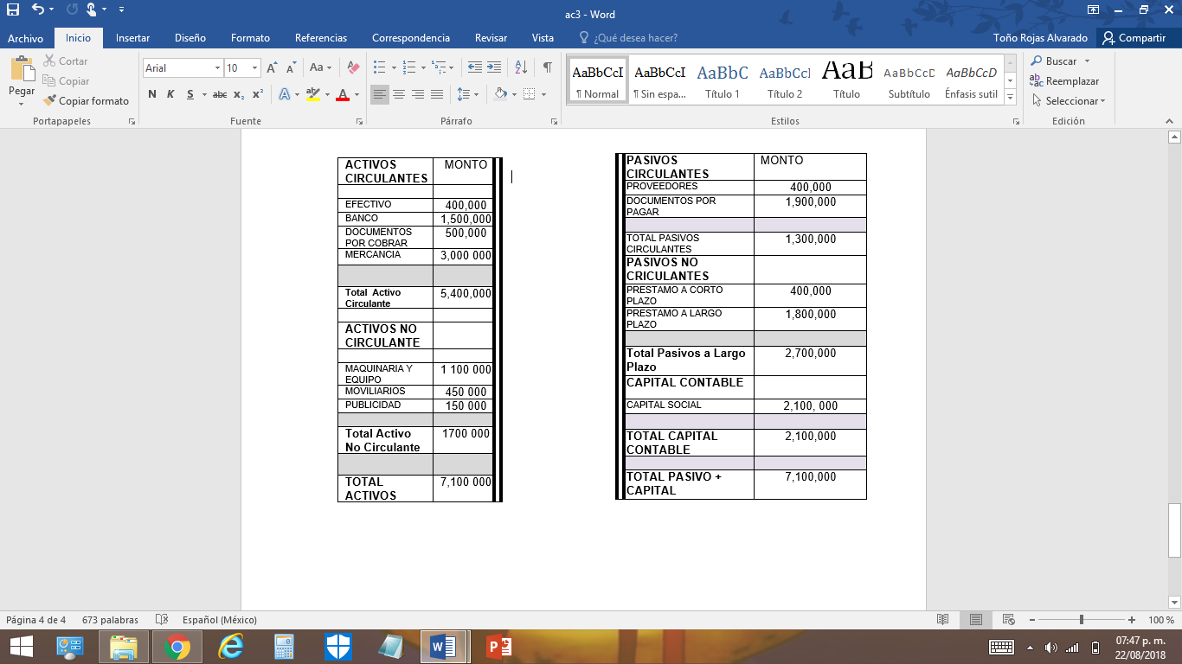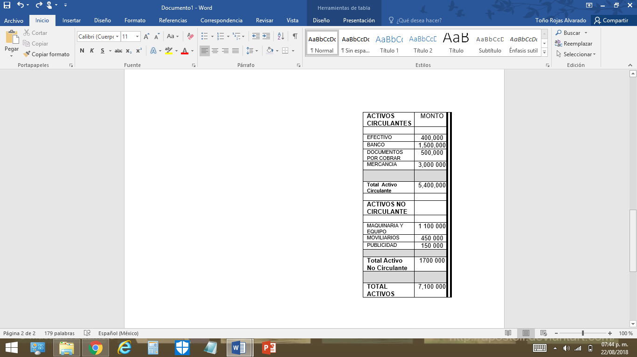Balanza de comprobación. 20 de agosto 2018 MXN

|  |  |  |
| --- | --- | --- |
| Cuentas | Debe | Haber |
| Activos:  Efectivo | 400,000 |  |
| Banco | 1,500,000 |  |
| Documentos por cobrar | 500,000 |  |
| Mercancía | 3,000,000 |  |
| Maquinaria y equipo | 1,100,000 |  |
| Honorarios | 4,500,000 |  |
| Publicidad | 150,000 |  |
| Pasivos:  Proveedores |  | 400,000 |
| Documentos por pagar |  | 1,900,000 |
| Préstamo a corto plazo |  | 900,000 |
| Préstamo a largo plazo |  | 1,800,000 |
| Capital contable:  Capital social |  | 2,100,000 |
| Sumas iguales | 7,100,000 | 7,100,000 |

*ELABORÓ (FIRMA): REVSÓ(FIRMA)*